**Practical session 2**

*For the practical part of this lab please save the Python programs that you create and take screenshots of the execution (evaluation) of your programs.*

**Tasks:**

1. **Write an algorithm that describes how to make scrambled eggs, try to use control words, like IF, WHEN, UNTIL, WHILE, WAIT, AND, OR.**
2. Get Eggs
3. Beat eggs together UNTIL blended
4. Pour oil onto frying pan and WAIT for oil to heat up
5. IF (oil is hot) add eggs
6. WHILE eggs are cooking add seasoning AND begin folding mixture within pan
7. Wait FOR mixture to be fully cooked
8. **Is Idle (the Python language shell) an Interpreter or a Compiler or both? Explain your answer.**

An interpreter, as it can only interpret and translate one piece of code at a time.

**3) Write a command in the Idle shell that says “Hello world”**

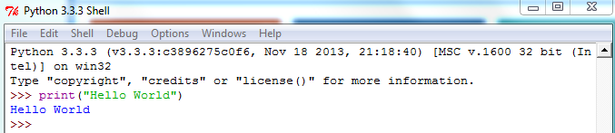

4) Write a program that produces the following output:

Hello World

I am in my ISD class right now

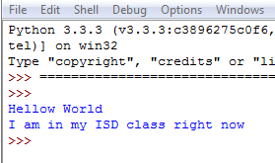

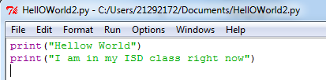

**Reminder on “Input”:**

A simple way to store variables (values) in your program is to use variables. Variables are placeholders that can store values, like strings (words), numbers (int) etc.

To create a variable, just give it a name and an initial value, for example for a number:

number = 7

or for a String (words):

myword = “This is my word”

5) Write a program that asks the user for his/her name and produces an output like:

Hi there, what is your name?

>User input to be read<

Hello

“User name”

How are you?

